TÀI LIỆU

CÀI ĐẶT CƠ SỞ DỮ LIỆU ORACLE 11GR2

**Phiên bản: 1.0**

**Mã tài liệu:**

**HÀ NỘI – 06/2016**

**MỤC LỤC**

1 Mục đích 4

2 Phạm vi áp dụng 4

3 Tài liệu liên quan 4

4 Yêu cầu 5

4.1 Yêu cầu đối với hệ thống 5

4.2 Yêu cầu phần mềm 5

5 Chuẩn bị 6

5.1 Edit File Hosts 6

5.2 Edit Kernel Parameters 6

5.3 Edit file limits.conf 7

5.4 Disable SELINUX 7

5.5 Disable Firewall 7

5.6 Install OS Package 8

5.6.1 Create Local Repository 8

5.6.2 Create Local Repository Configuration File 8

5.7 Install OS Package 9

5.8 Tạo User, Group 9

5.9 Tạo đường dẫn 9

5.10 Cấu hình tmpfs 10

5.11 Set biến môi trường 10

5.12 Config ASMLIB 11

6 Cài đặt Grid Infrastructure 12

6.1 Giải nén bộ cài 12

6.2 Cài đặt Infrastructure Software 12

6.3 Tạo diskgroup 22

7 Cài đặt Database 25

7.1 Giải nén bộ cài 25

7.2 Cài đặt Database Software 25

7.3 Cài đặt database 34

7.4 Kiểm tra kết quả 44

# Mục **đích**

Cài đặt Oracle Database Software phiên bản 12.1.0.

# Phạm vi áp dụng

Sử dụng trong dự án “”.

# Tài liệu liên quan

|  |  |  |  |
| --- | --- | --- | --- |
| **STT** | **Mã hiệu** | **Tên tài liệu** | **Ghi chú** |
| 1 |  | Oracle® Database Installation Guide 12 Release 1 (12.1) for Linux Enterprise 6 |  |

# Yêu cầu

## Yêu cầu đối với hệ thống

OS : Red Hat 6

RAM > 4GB

Swap > 4GB

/tmp > 2GB

Lệnh kiểm tra RAM

# cat /proc/meminfo | grep MemTotal

MemTotal: 65932788 kB

Lệnh kiểm tra Swap

# cat /proc/swaps

Filename Type Size Used Priority

/dev/sda3 partition 134217720 0 -1

Lệnh kiểm tra /tmp

# df -h /tmp

Filesystem Size Used Avail Use% Mounted on

/dev/sda8 7.9G 147M 7.4G 2% /tmp

## Yêu cầu phần mềm

* Bộ cài Database 12.1.0.2 cho Linux x64
* Đĩa cài đặt OS được Mount vào ổ CD-ROM để cài đặt OS Packages
* Download Package pdksh-5.2.14-1.i386.rpm

# Chuẩn bị

## Edit File Hosts

* Login với User Root

Sửa file **/etc/hosts**

# vi /etc/hosts

Thêm vào cuối file các dòng sau: ( địa chỉ ip – tên hostname)

10.0.98.99 Linux6Ent

## Edit Kernel Parameters

* Login với User Root

Sửa file **/etc/sysctl.conf**

# vi /etc/sysctl.conf

Thêm vào cuối file các dòng sau:

fs.suid_dumpable = 1

fs.aio-max-nr = 1048576

fs.file-max = 6815744

kernel.shmall = 11010048

kernel.shmmax = 45097156608

kernel.shmmni = 4096

# semaphores: semmsl, semmns, semopm, semmni

kernel.sem = 250 32000 100 128

net.ipv4.ip_local_port_range = 9000 65500

net.core.rmem_default=4194304

net.core.rmem_max=4194304

net.core.wmem_default=262144

net.core.wmem_max=1048586

Chạy lệnh sau

# sysctl -p

## Edit file limits.conf

* Login với User Root

Sửa file **/etc/security/limits.conf**

# vi /etc/security/limits.conf

Thêm vào cuối file các dòng sau:

grid soft nproc 2047

grid hard nproc 16384

grid soft nofile 1024

grid hard nofile 65536

oracle soft nproc 2047

oracle hard nproc 16384

oracle soft nofile 1024

oracle hard nofile 65536

## Disable SELINUX

* Login với User Root

Kiểm tra file /etc/selinux/config

* Nếu SELINUX=disable thì giữ nguyên không thay đổi
* Nếu không thì sửa thành SELINUX=disable

# vi /etc/selinux/config

# This file controls the state of SELinux on the system.

# SELINUX= can take one of these three values:

# enforcing - SELinux security policy is enforced.

# permissive - SELinux prints warnings instead of enforcing.

# disabled - SELinux is fully disabled.

SELINUX=disabled

# SELINUXTYPE= type of policy in use. Possible values are:

# targeted - Only targeted network daemons are protected.

# strict - Full SELinux protection.

SELINUXTYPE=targeted

## Disable Firewall

* Login với User Root

Chạy lệnh sau

# chkconfig iptables off

# service iptables stop

## Install OS Package

* Đưa đĩa cài đặt Red Hat 6.5 vào ổ CD-ROM

### Create Local Repository

* Chú ý trong bước này có đoạn phải tiến hành Copy Package từ ngoài đĩa CD-ROM vào (Dòng bôi đỏ)
* Login với User Root

# mount /dev/cdrom /media/

# cd /media/Packages

# rpm -Uvh deltarpm-3.5-0.5.20090913git.el6.x86_64.rpm

# rpm -Uvh python-deltarpm-3.5-0.5.20090913git.el6.x86_64.rpm

# rpm -Uvh createrepo-0.9.9-18.el6.noarch.rpm

Chú ý: Trong quá trình cài đặt phiên bản của các gói thư viện có thể khác, đánh tên gói thư viện ( deltarpm, python, createrepo...) và ấn tab để có chính xác gói có trong đĩa cài đặt )

# mkdir /u01/repo

# cp * /u01/repo/

# cd ..

# rpm --import RPM-GPG-KEY-redhat-beta RPM-GPG-KEY-redhat-release

Download và copy Package pdksh-5.2.14-1.i386.rpm vào /u01/repo/

# cd /u01/repo/

# createrepo /u01/repo/

### Create Local Repository Configuration File

* Login với User Root

Tạo file **my_local.repo**

# vi /etc/yum.repos.d/my_local.repo

Thêm vào những dòng sau:

[localrepo]

name=local_repo

baseurl=file:///u01/repo/

enabled=1

gpgcheck=0

## Install OS Package

* Login với User Root

# cd /u01/repo/

# yum install -y binutils gcc gcc-c++ glibc-devel libgcc compat-libcap1 ksh libstdc++ make compat-db libXp pdksh sysstat libaio-devel compat-libstdc++-33 elfutils-libelf-devel kmod-oracleasm oracleasmlib oracleasm-support –nogpgcheck

## Tạo User, Group

* Login với User Root
* Tạo user Oracle để phục vụ việc cài đặt Oracle Software
* Chú ý dòng bôi đỏ

+FOR GRID:

# groupadd -g 1000 oinstall

# groupadd -g 1200 asmadmin

# groupadd -g 1201 asmdba

# groupadd -g 1202 asmoper

# useradd -m -u 1100 -g oinstall -G asmadmin,asmdba,asmoper -d /home/grid -s /bin/bash -c "Grid Infrastructure Owner" grid

# passwd grid

+FOR ORACLE:

# groupadd -g 1300 dba

# groupadd -g 1301 oper

# useradd -m -u 1101 -g oinstall -G dba,oper,asmdba -d /home/oracle -s /bin/bash -c "Oracle Software Owner" oracle

# passwd oracle

## Tạo đường dẫn

- Login với User Root

# mkdir -p /u01/app/oracle

# mkdir -p /u01/app/oracle/product/11.2/dbhome_1

# chown -R oracle:oinstall /u01/app

# chmod -R 775 /u01/app/oracle

# chmod -R 775 /u01/app/oracle/product/11.2/dbhome_1

## Cấu hình tmpfs

Login với User Root

Truy cập vào file **/etc/fstab**:

# vi /etc/fstab

Tìm và sửa dòng **tmpfs** như sau:

tmpfs /dev/shm tmpfs defaults 0 0

Chạy lệnh sau:

# mount -o remount /dev/shm

## Set biến môi trường

- Login với User Oracle

Sửa file **/home/oracle/.bash_profile**

$ vi /home/oracle/.bash_profile

Thêm vào cuối file các dòng sau:

ORACLE_BASE=/u01/app/oracle

export ORACLE_BASE

ORACLE_HOME=/u01/app/oracle/11.2.0/db

export ORACLE_HOME

ORACLE_SID=mediadb

export ORACLE_SID

SHLIB_PATH=$ORACLE_HOME/lib32:$ORACLE_HOME/rdbms/lib32

export SHLIB_PATH

PATH=$PATH:$ORACLE_HOME/bin

export PATH

CLASSPATH=$ORACLE_HOME/JRE:$ORACLE_HOME/jlib:$ORACLE_HOME/rdbms/jlib/:$ORACLE_HOME/network/jlib

export CLASSPATH

umask 022

Thực hiện đọc file **/home/oracle/.bash_profile**

$ source /home/oracle/.bash_profile

Login với User Grid

ORACLE_SID=+ASM

export ORACLE_SID

ORACLE_BASE=/u01/app/grid

export ORACLE_BASE

ORACLE_HOME=/u01/app/11.2.0/grid

export ORACLE_HOME

SHLIB_PATH=$ORACLE_HOME/lib32:$ORACLE_HOME/rdbms/lib32

export SHLIB_PATH

PATH=$PATH:$ORACLE_HOME/bin

export PATH

CLASSPATH=$ORACLE_HOME/JRE:$ORACLE_HOME/jlib:$ORACLE_HOME/rdbms/jlib/:$ORACLE_HOME/network/jlib

export CLASSPATH

umask 022

## Config ASMLIB

* Login với User Root

# /usr/sbin/oracleasm configure -i

Configuring the Oracle ASM library driver.

This will configure the on-boot properties of the Oracle ASM library

driver. The following questions will determine whether the driver is

loaded on boot and what permissions it will have. The current values

will be shown in brackets ('[]'). Hitting <ENTER> without typing an

answer will keep that current value. Ctrl-C will abort.

Default user to own the driver interface []:

grid

Default group to own the driver interface []:

asmadmin

Start Oracle ASM library driver on boot (y/n) [n]:

y

Scan for Oracle ASM disks on boot (y/n) [y]:

y

Writing Oracle ASM library driver configuration: done

# /usr/sbin/oracleasm init

Creating /dev/oracleasm mount point: /dev/oracleasm

Loading module "oracleasm": oracleasm

Mounting ASMlib driver filesystem: /dev/oracleasm

[root@racnode1 ~]# /usr/sbin/oracleasm createdisk CRSVOL1 /dev/iscsi/crs1/part1

Writing disk header: done

Instantiating disk: done

[root@racnode1 ~]# /usr/sbin/oracleasm createdisk DATAVOL1 /dev/iscsi/crs1/part1

Writing disk header: done

Instantiating disk: done

[root@racnode1 ~]# /usr/sbin/oracleasm createdisk FRAVOL1 /dev/iscsi/crs1/part1

Writing disk header: done

Instantiating disk: done

# Cài đặt Grid Infrastructure

## Giải nén bộ cài

* Thực hiện với User Root
* Copy bộ cài Oralce vào **/u01** và thực hiện giải nén ( đánh tên file nén chính xác )

# cd /u01

# unzip grid_1201020_Linux-x86-64_1of7.zip

# unzip grid_1201020_Linux-x86-64_2of7.zip

# chown -R grid:oinstall grid

## Cài đặt Infrastructure Software

* Login với User Oracle
* Máy tính tiến hành Remote phải được cài đặt và bật X-Passive ( X-Server, XMing ...)
* Thay IP bôi đỏ phía dưới bằng IP của máy tiến hành Remote

$ cd /u01/grid

$ export DISPLAY=10.0.1.10:0.0

$ ./runInstaller

* Làm theo các hướng dẫn trong hình:

Select the "Install and Configure Oracle Grid Infrastructure for a Cluster" option, then click the "Next" button.

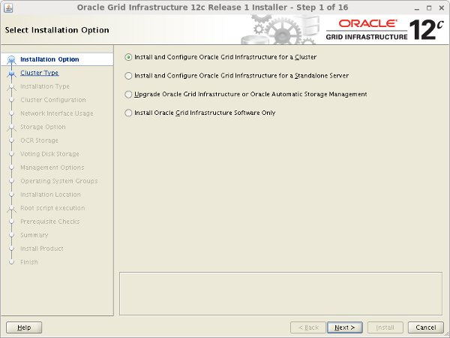

Accept the "Configure a Standard cluster" option by clicking the "Next" button.

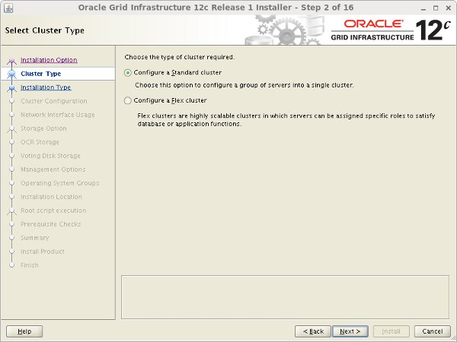

Select the "Typical Installation" option, then click the "Next" button.

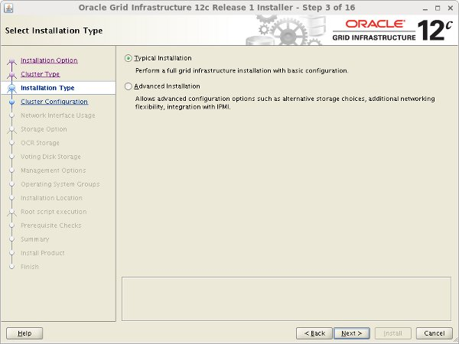

On the "Specify Cluster Configuration" screen, enter the correct SCAN Name and click the "Add" button.

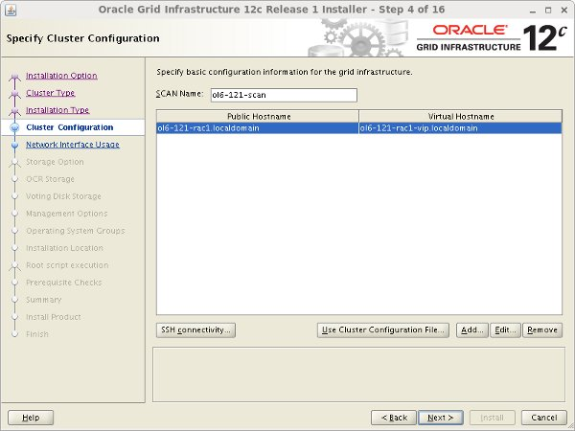

Enter the details of the second node in the cluster, then click the "OK" button.

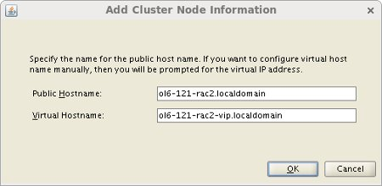

Click the "SSH Connectivity..." button and enter the password for the "oracle" user. Click the "Setup" button to configure SSH connectivity, and the "Test" button to test it once it is complete. Once the test is complete, click the "Next" button.

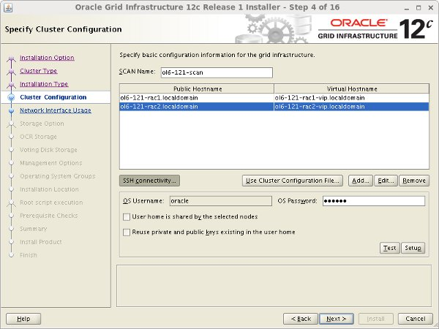

If you are doing a 12.1.0.1 installation, you will have to click the "Identify network interfaces" button, but in 12.1.0.2 this is on the following screen.

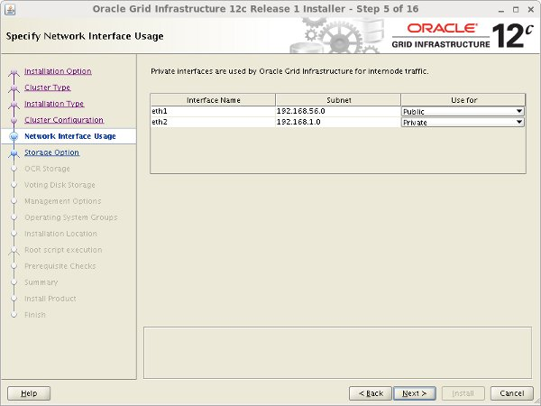

Enter software location and "Automatic Storage Manager" as the cluster registry storage type. Enter the ASM password, select "dba" as the group and click the "Next" button.

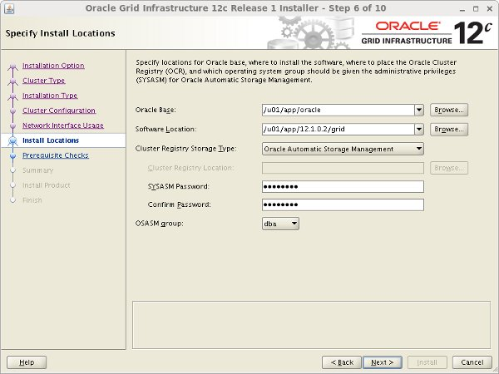

Set the redundancy to "External", click the "Change Discovery Path" button and set the path to "/dev/asm*". Return the main screen and select all 4 disks and click the "Next" button.

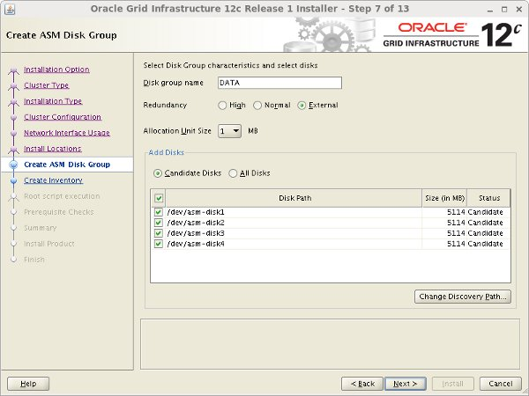

Accept the default inventory directory by clicking the "Next" button.

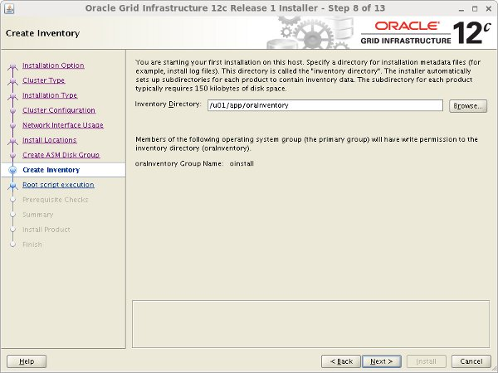

If you want the root scripts to run automatically, enter the relevant credentials. I prefer to run them manually. Click the "Next" button.

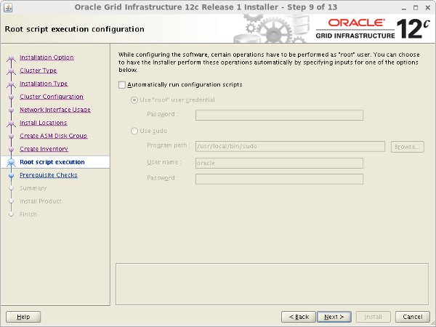

Wait while the prerequisite checks complete. If you have any issues use the "Fix & Check Again" button. Once possible fixes are complete, check the "Ignore All" checkbox and click the "Next" button. It is likely the "Physical Memory" and "Device Checks for ASM" tests will fail for this type of installation. This is OK.

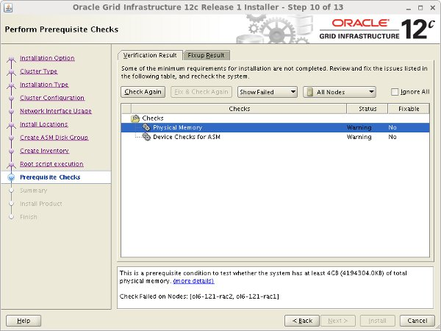

If you are happy with the summary information, click the "Install" button.

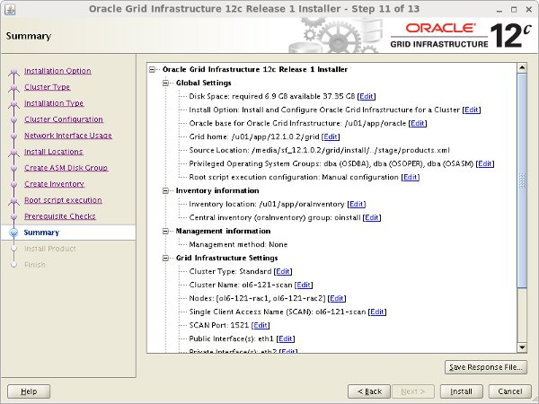

Wait while the installation takes place.

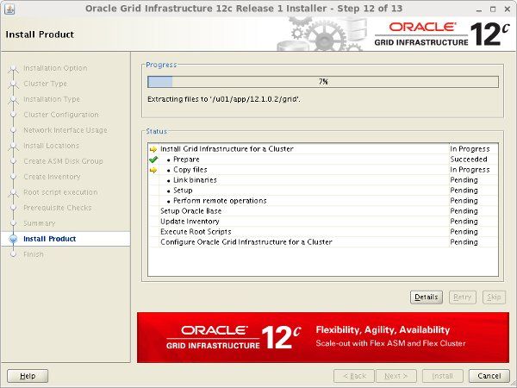

When prompted, run the configuration scripts on each node.

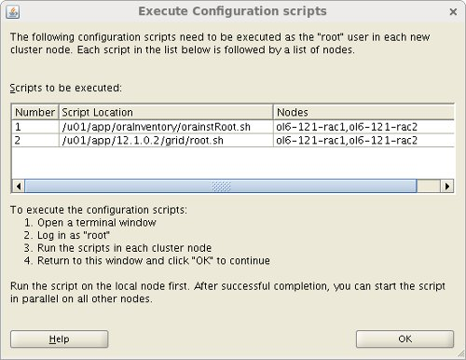

The output from the "orainstRoot.sh" file should look something like that listed below.

# /u01/app/oraInventory/orainstRoot.sh

Changing permissions of /u01/app/oraInventory.

Adding read,write permissions for group.

Removing read,write,execute permissions for world.

Changing groupname of /u01/app/oraInventory to oinstall.

The execution of the script is complete.

#

The output of the "root.sh" will vary a little depending on the node it is run on. Example output can be seen here ([Node1](https://oracle-base.com/articles/12c/images/ol6-121-rac/12cR1_node1_root_sh.txt), [Node2](https://oracle-base.com/articles/12c/images/ol6-121-rac/12cR1_node2_root_sh.txt)).

Once the scripts have completed, return to the "Execute Configuration Scripts" screen on "ol6-121-rac1" and click the "OK" button.



Wait for the configuration assistants to complete.

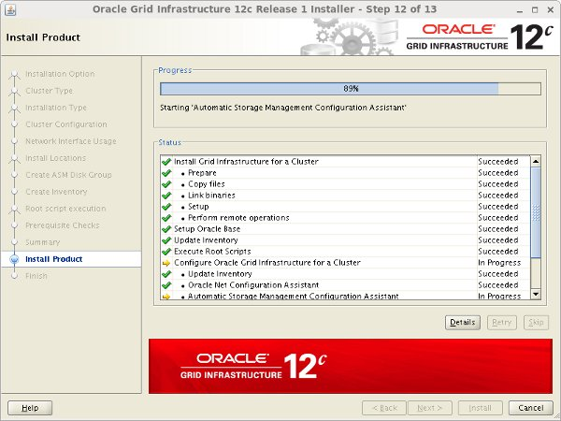

Click the "Close" button to exit the installer.

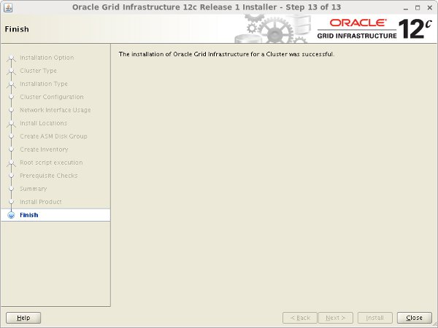

## Tạo diskgroup

* Thực hiện trên node1
* Truy cập vào user grid để tiến hành tạo diskgroup cho asm

[grid@racnode1 ~]$ asmca

* Làm như những hình sau :

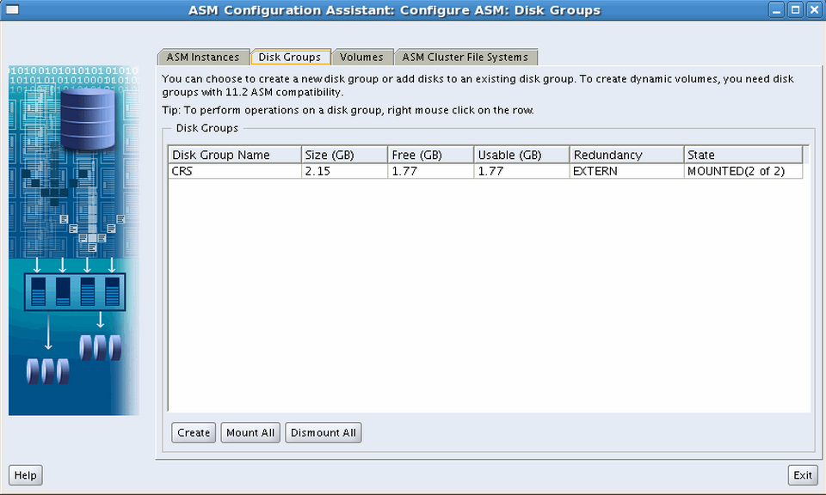

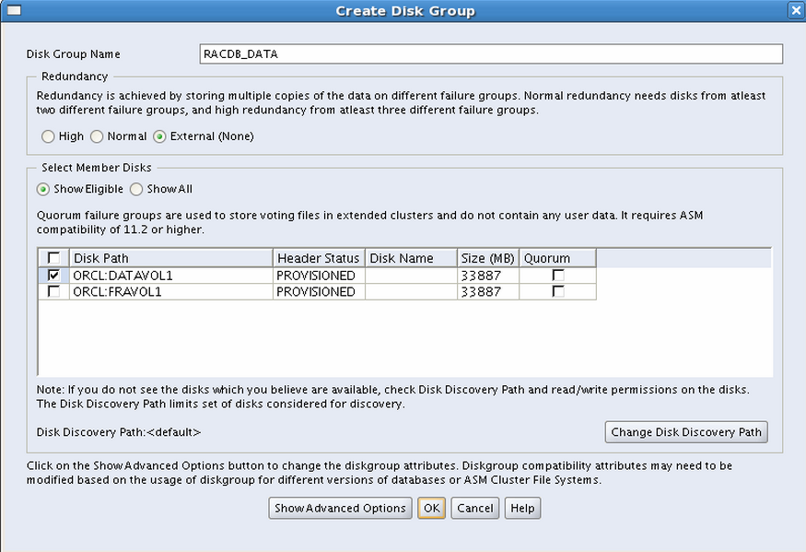

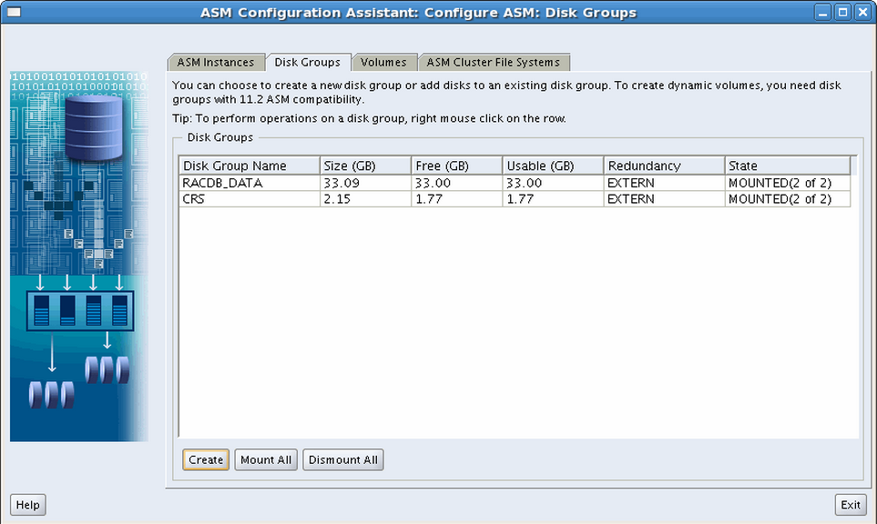

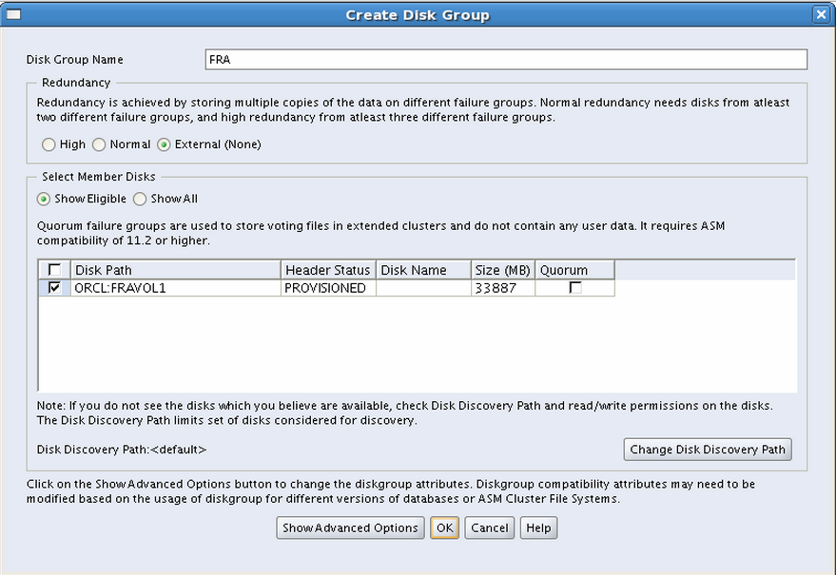

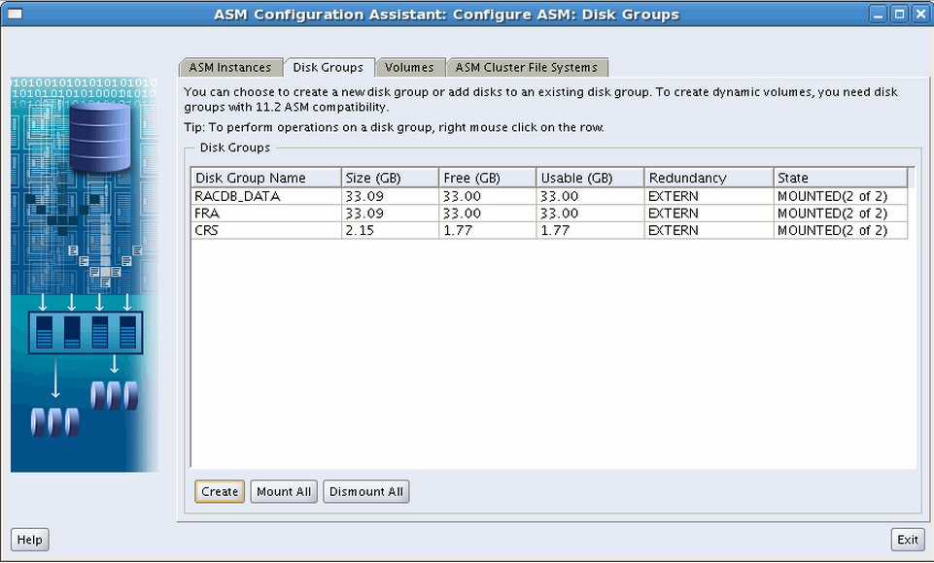

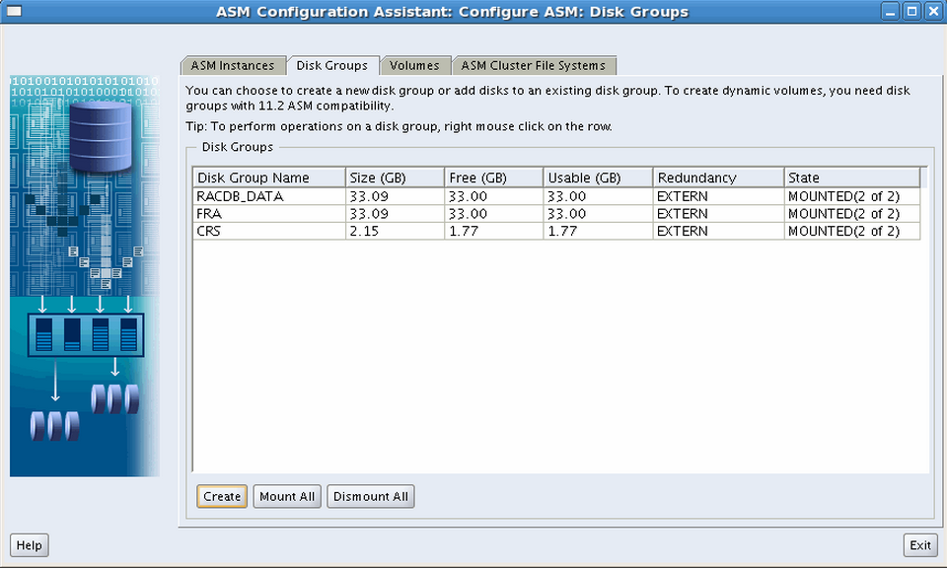

# Cài đặt Database

## Giải nén bộ cài

* Thực hiện với User Root
* Copy bộ cài Oralce vào **/u01** và thực hiện giải nén ( đánh tên file nén chính xác )

# cd /u01

# unzip database_1201020_Linux-x86-64_1of7.zip

# unzip database_1201020_Linux-x86-64_2of7.zip

# chown -R oracle:oinstall database

## Cài đặt Database Software

* Login với User Oracle
* Máy tính tiến hành Remote phải được cài đặt và bật X-Passive ( X-Server, XMing ...)
* Thay IP bôi đỏ phía dưới bằng IP của máy tiến hành Remote

$ cd /u01/database

$ export DISPLAY=10.0.1.10:0.0

$ ./runInstaller

The installer will start and you will see the screen like below.

[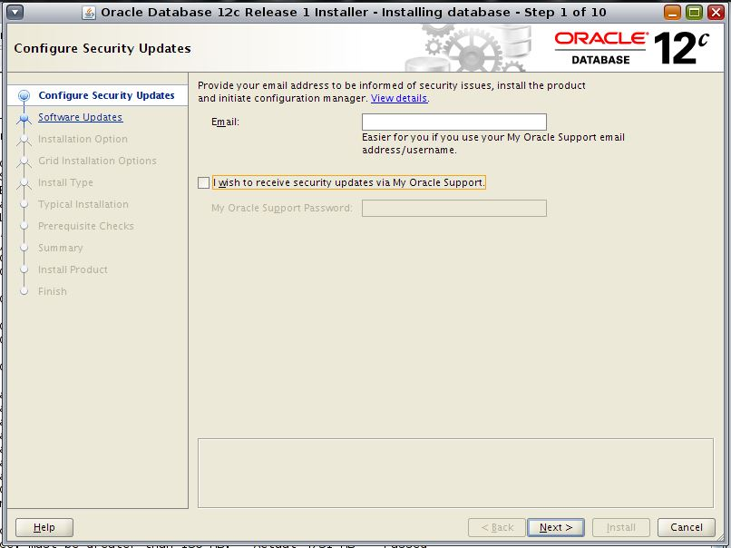](http://www.vitalsofttech.com/wp-content/uploads/2013/07/Fig-1.jpg)

 You can skip this step and click Next.

[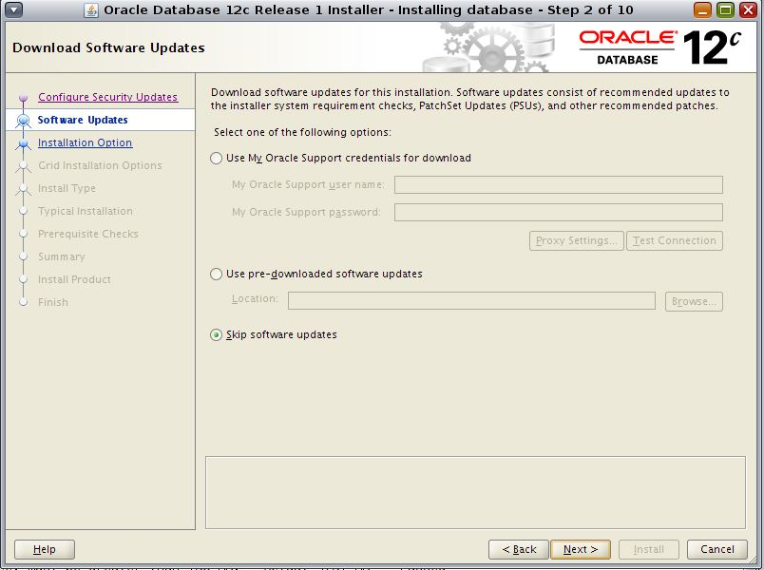](http://www.vitalsofttech.com/wp-content/uploads/2013/07/Fig-2.jpg)

Install database software only Next

[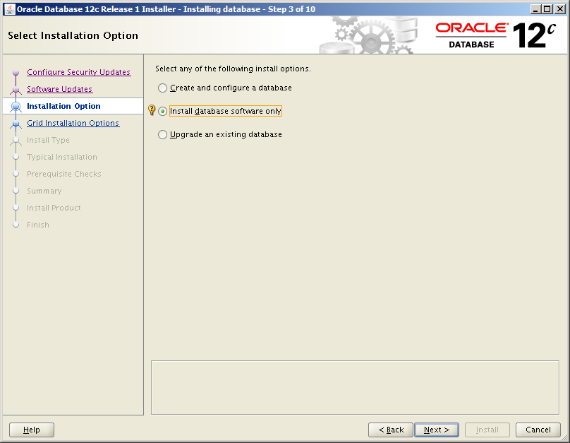](http://www.snapdba.com/wp-content/uploads/2013/07/088e1f2906ab0c65add0b77b353cef83.png)

Single instance database installation Next

[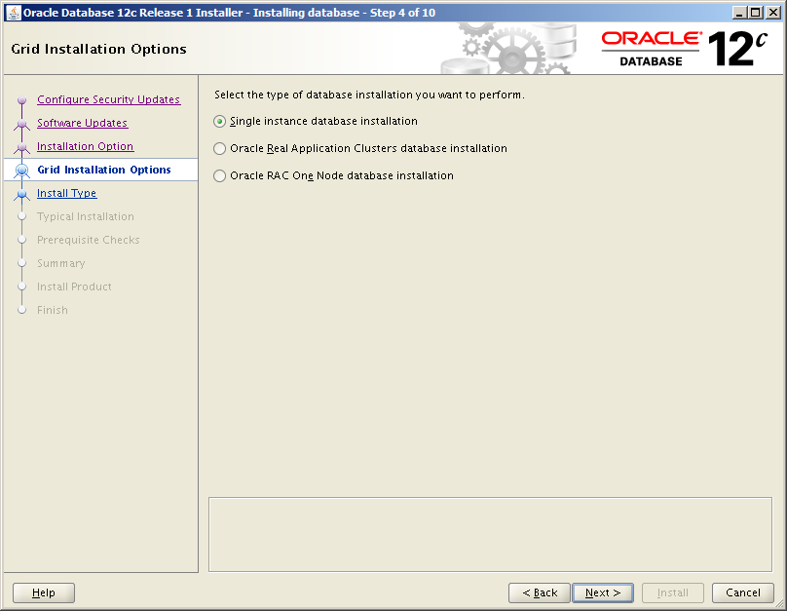](http://www.snapdba.com/wp-content/uploads/2013/07/78ed43b8b5a2ea64bc22a73e35547027.png)

Select any additional required languages and move across, otherwise leave just the default ‘English’ selected Next

[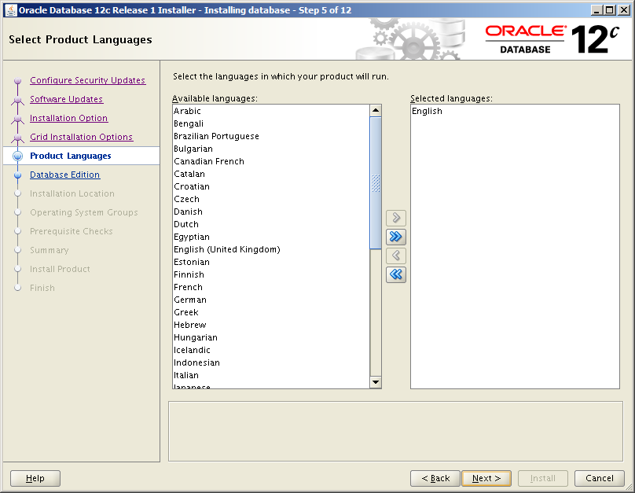](http://www.snapdba.com/wp-content/uploads/2013/07/9524d17f6b5f08bd58b3fff63e752157.png)

Enterprise Edition (6.4GB) . Next

[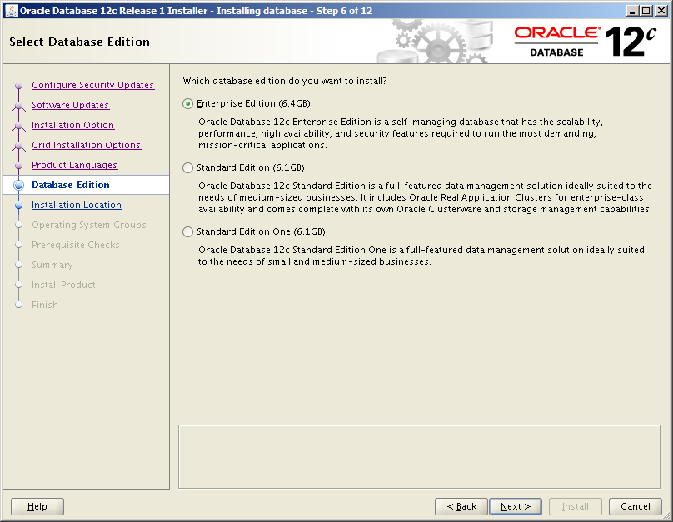](http://www.snapdba.com/wp-content/uploads/2013/07/935b2aceb6a6b41917c04a9fa863eea5.png)

* Oracle Base: /u01/app/oracle
* Software Location: /u01/app/oracle/product/12.1.0.1

[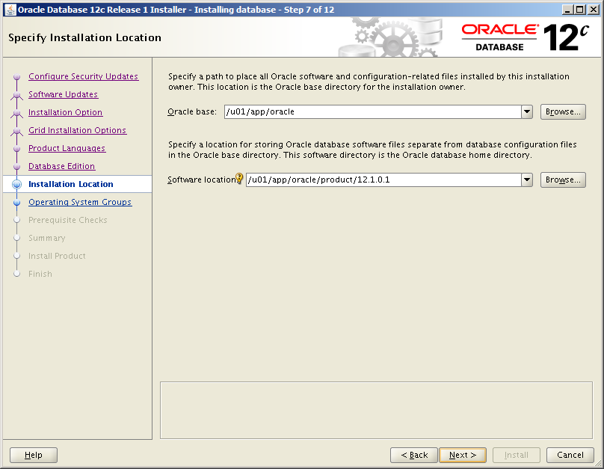](http://www.snapdba.com/wp-content/uploads/2013/07/9f47283fac569be8edf94244d0841f81.png)

Inventory Directory: /u01/app/oraInventory

oraInventory Group Name: oinstall

[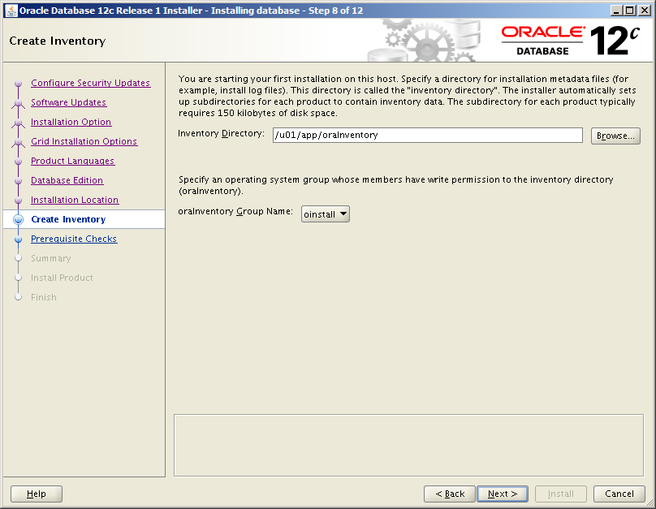](http://www.snapdba.com/wp-content/uploads/2013/07/4970e53de15381114c365c47226b42c1.png)

Database Administrator (OSDBA) group: dba

Database Operator (OSOPER) group (Optional): dba

Leave all the other memberships as the default ‘dba’ group too.

[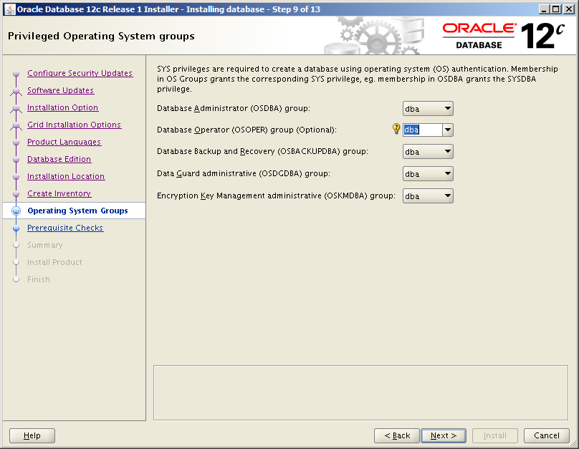](http://www.snapdba.com/wp-content/uploads/2013/07/a28b2da1d6a873b986b6a420e15779a8.png)

All prerequisite checks should complete successfully here

[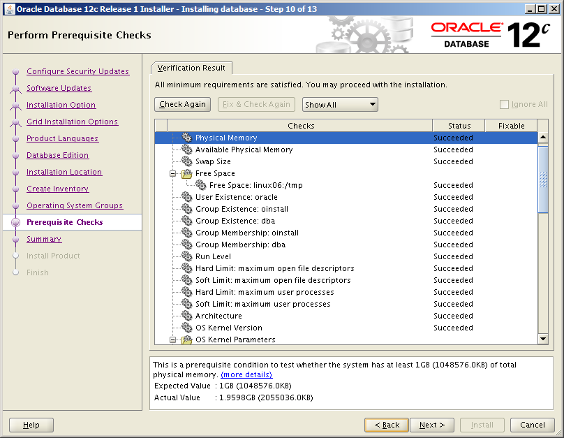](http://www.snapdba.com/wp-content/uploads/2013/07/f86a50d500fdedbf8bd269407ad3ec87.png)

Check everything is correct!

Click Install

[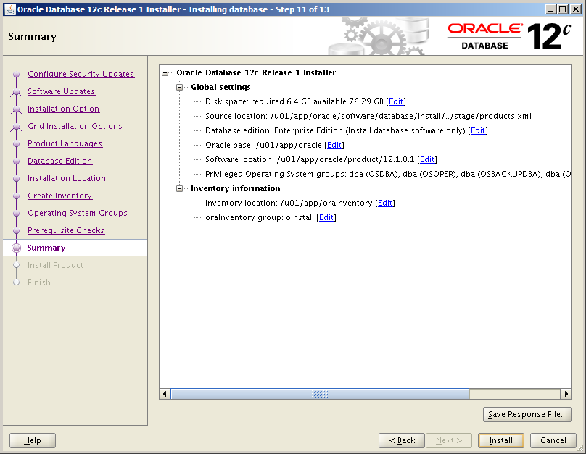](http://www.snapdba.com/wp-content/uploads/2013/07/a879fa1f0e6ec411b049b8ba57e9a080.png)

[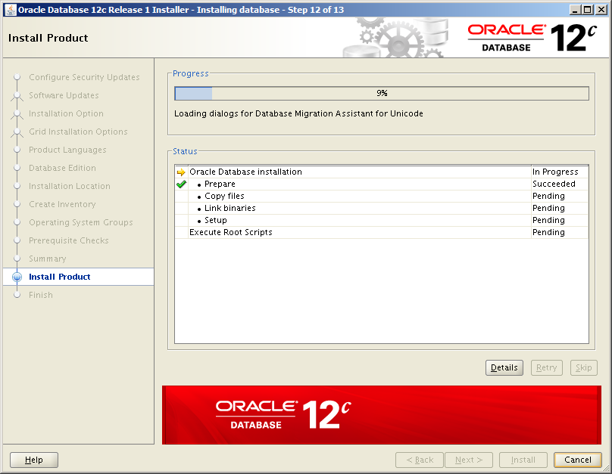](http://www.snapdba.com/wp-content/uploads/2013/07/ed1335b8d08c88dec04ac74fab68e441.png)

[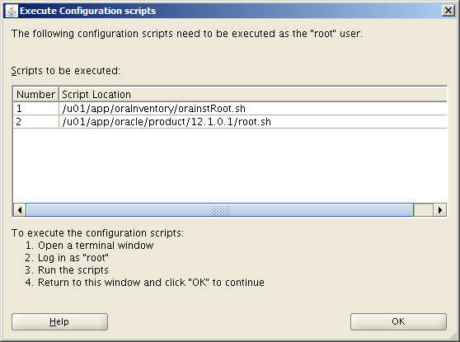](http://www.snapdba.com/wp-content/uploads/2013/07/3479fab3571d167e505fce34de1aaa42.png)

Run the root.sh script(s)

When prompted, run the following as root:

/u01/app/oraInventory/orainstRoot.sh (first Oracle installations only)

[root@linux06 ~]# /u01/app/oraInventory/orainstRoot.sh

Changing permissions of /u01/app/oraInventory.

Adding read,write permissions for group.

Removing read,write,execute permissions for world.

/u01/app/oracle/product/12.1.0.1/root.sh

[root@linux06 ~]# /u01/app/oracle/product/12.1.0.1/root.sh

Performing root user operation for Oracle 12c

The following environment variables are set as:

ORACLE_OWNER= oracle

ORACLE_HOME= /u01/app/oracle/product/12.1.0.1

Enter the full pathname of the local bin directory: [/usr/local/bin]: <enter>

Copying dbhome to /usr/local/bin ...

Copying oraenv to /usr/local/bin ...

Copying coraenv to /usr/local/bin ...

Creating /etc/oratab file...

Entries will be added to the /etc/oratab file as needed by

Database Configuration Assistant when a database is created

Finished running generic part of root script.

Now product-specific root actions will be performed.

Finally, click close to finish, and you’re all done

## Cài đặt database

* Login với User Oracle
* Máy tính tiến hành Remote phải được cài đặt và bật X-Passive ( X-Server, XMing ...)
* Thay IP bôi đỏ phía dưới bằng IP của máy tiến hành Remote

$ export DISPLAY=10.0.1.10:0.0

$ dbca

* Chọn **Next**

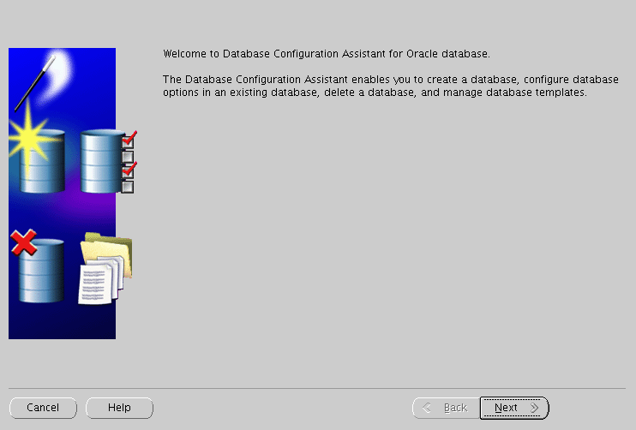

* Chọn **Create a Database**
* Chọn **Next**

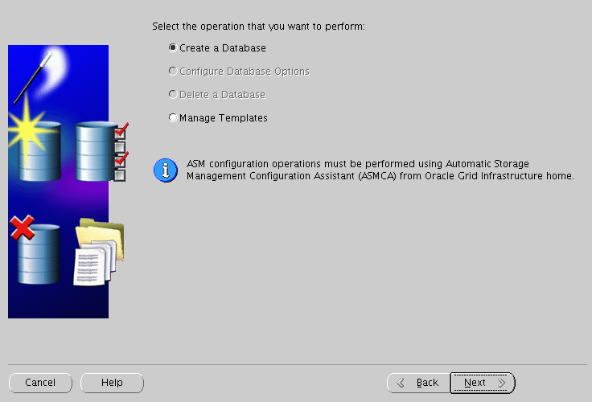

* Chọn **Genetal Purpose or Transaction Processing**
* Chọn **Next**

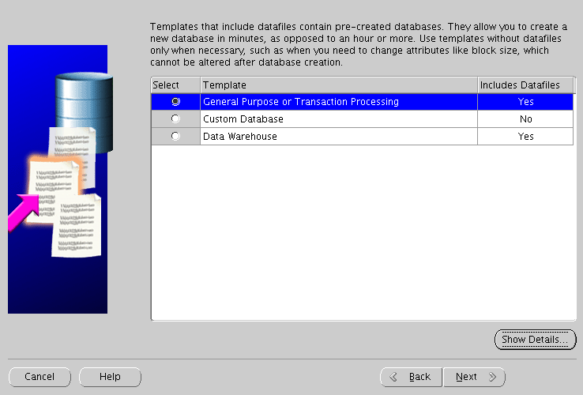

* Điền tên cho database : db01
* Chọn **Next**

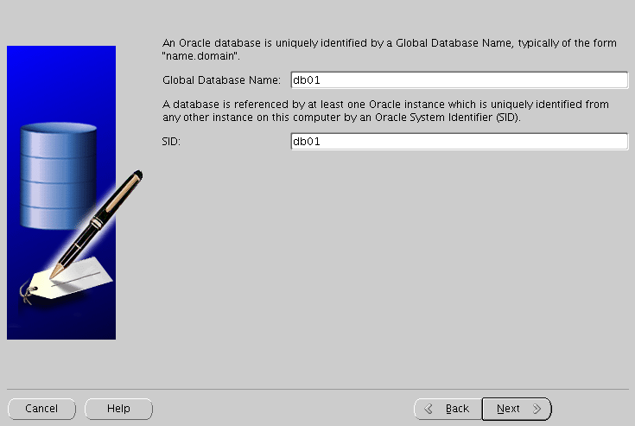

* Bỏ tích **Configure Enterprise Manager**
* Chọn **Next**

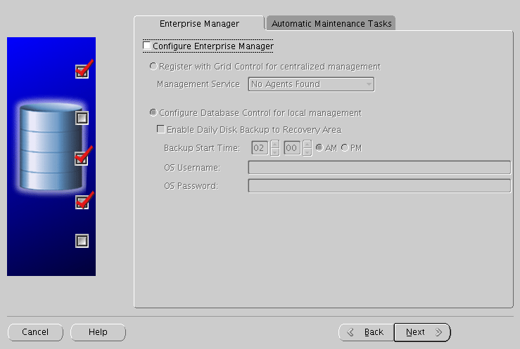

* Chọn **Use the Same Administrative Password for All Accounts**
* Điền password và chọn **Next**

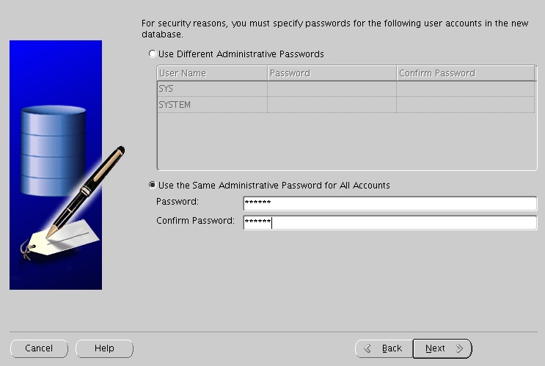

* Chon **Use Database File Location from Template**
* Chọn **Next**

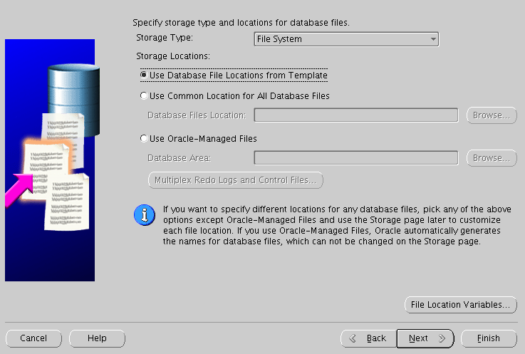

* Chọn **Specify Fast Recovery Area**
* Chọn **Next**

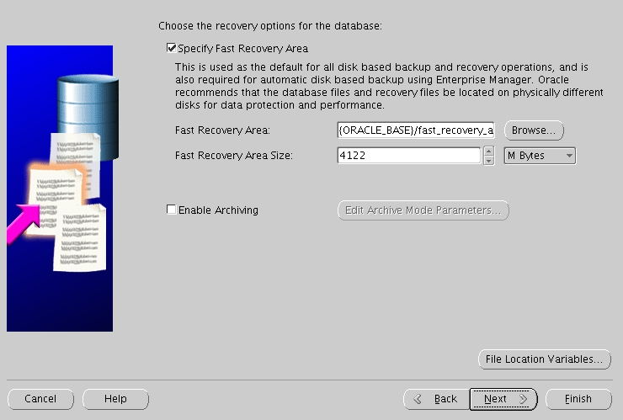

* Chọn **Next**

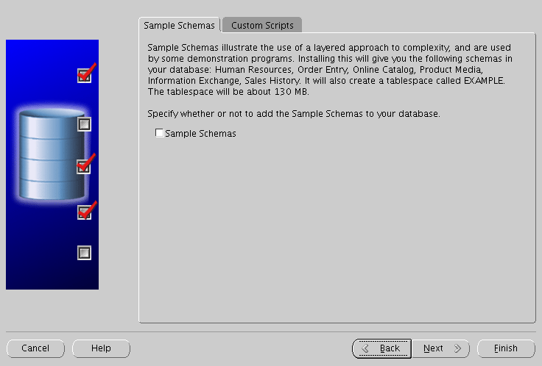

* Chọn Typical: **40% percenntage**
* Chọn **Use Automatic Memory Management**
* Chọn **Tab Sizing**

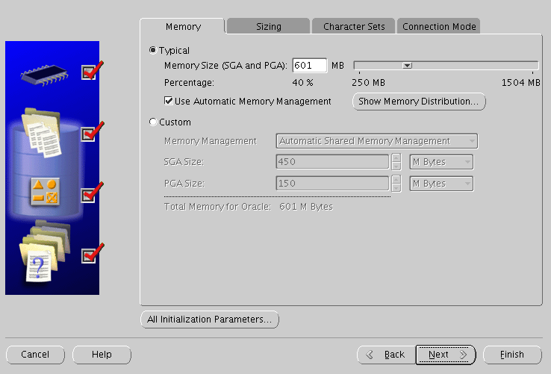

* Điền Processes: **300**
* Chọn **Tab Character Sets**

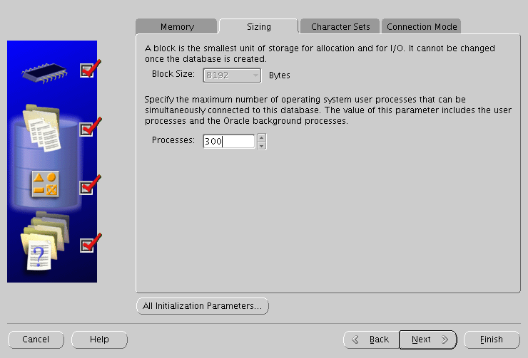

* Chọn **Use Unicode AL32UTF8**
* Chọn **National Character Set : UTF8 – Unicode 3.0 UTF …**
* Chọn **Default Langue : America**
* Chọn **Default Terrioty : United States**
* Chọn **Next**

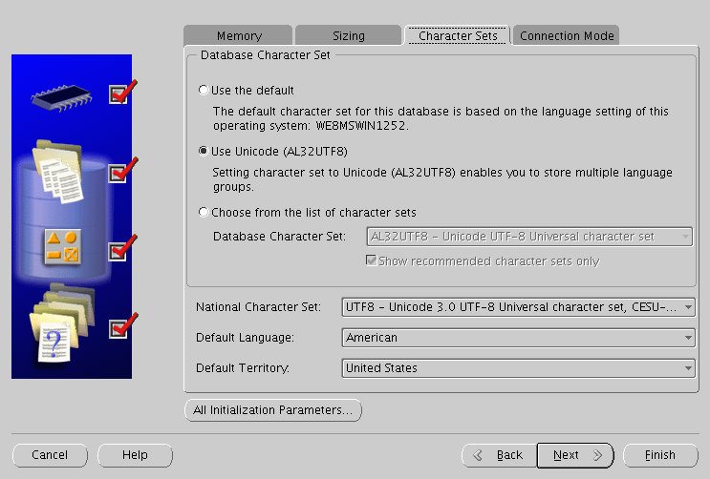

* Chọn **Next**

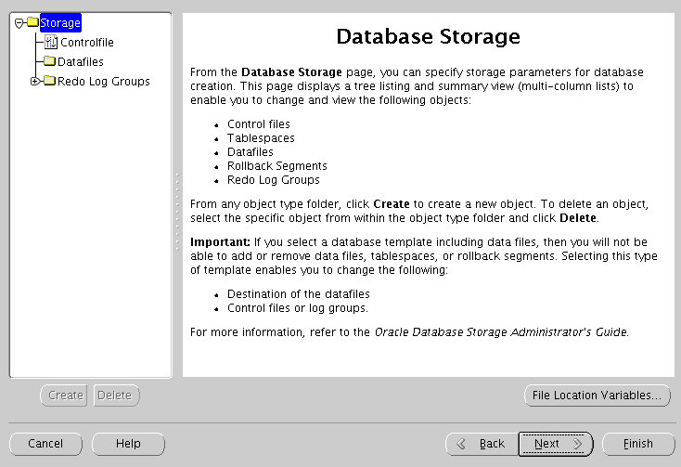

* Chọn **Create Database**
* Chọn **Finish**

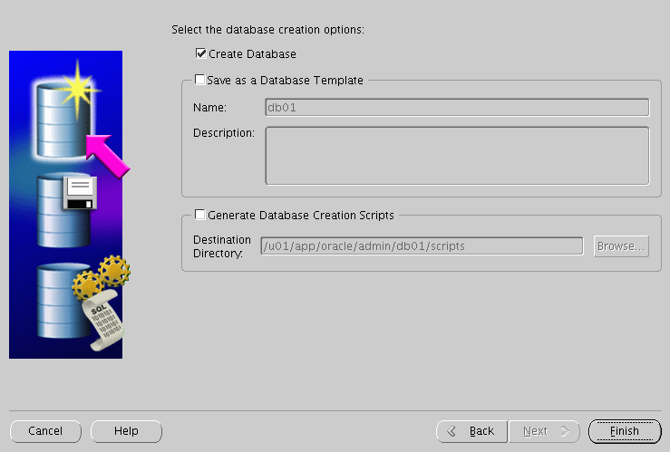

* Chọn **Ok**

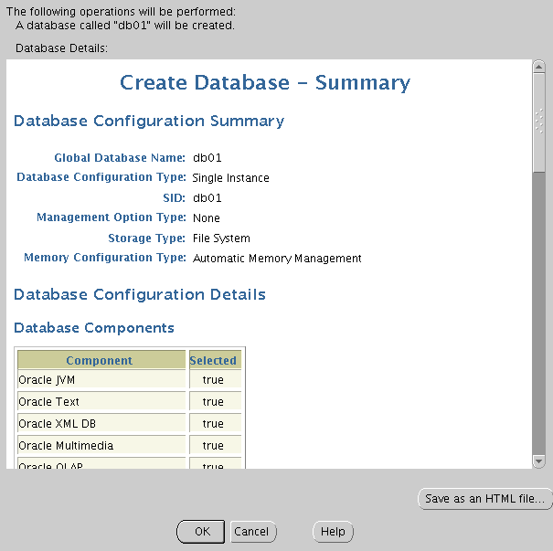

* Chờ đợi quá trình hoàn thành

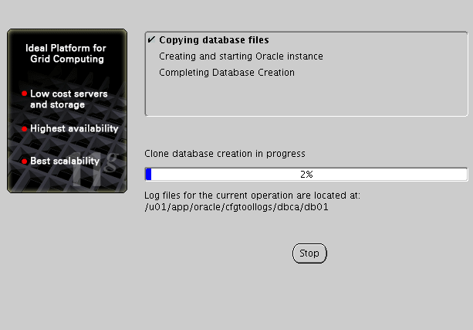

## Kiểm tra kết quả

* Login với User Oracle

$ **lsnrctl status**

LSNRCTL for Linux: Version 11.2.0.3.0 - Production on 14-JAN-2015 20:05:26

Copyright (c) 1991, 2011, Oracle. All rights reserved.

Connecting to (ADDRESS=(PROTOCOL=tcp)(HOST=)(PORT=1521))

STATUS of the LISTENER

------------------------

Alias LISTENER

Version TNSLSNR for Linux: Version 11.2.0.3.0 - Production

Start Date 14-JAN-2015 20:04:11

Uptime 0 days 0 hr. 1 min. 16 sec

Trace Level off

Security ON: Local OS Authentication

SNMP OFF

Listener Parameter File /u01/app/oracle/product/11.2.0/dbhome_1/network/admin/listener.ora

Listener Log File /u01/app/oracle/diag/tnslsnr/rhel6/listener/alert/log.xml

Listening Endpoints Summary...

(DESCRIPTION=(ADDRESS=(PROTOCOL=tcp)(HOST=rhel6)(PORT=1521)))

Services Summary...

Service "db01" has 1 instance(s).

Instance "db01", status READY, has 1 handler(s) for this service...

Service "db01XDB" has 1 instance(s).

Instance "db01", status READY, has 1 handler(s) for this service...

The command completed successfully

$ **sqlplus / as sysdba**

SQL*Plus: Release 11.2.0.3.0 Production on Wed Jan 14 09:15:46 2015

Copyright (c) 1982, 2011, Oracle. All rights reserved.

Connected to:

Oracle Database 11g Enterprise Edition Release 11.2.0.3.0 - 64bit Production

With the Partitioning, OLAP, Data Mining and Real Application Testing options

SQL> show parameter name

NAME TYPE VALUE

------------------------------------ ----------- ------------------------------

db_file_name_convert string

db_name string db01

db_unique_name string db01

global_names boolean FALSE

instance_name string db01

lock_name_space string

log_file_name_convert string

processor_group_name string

service_names string db01